How to Build your Online Presence that supports your Professional Resume?

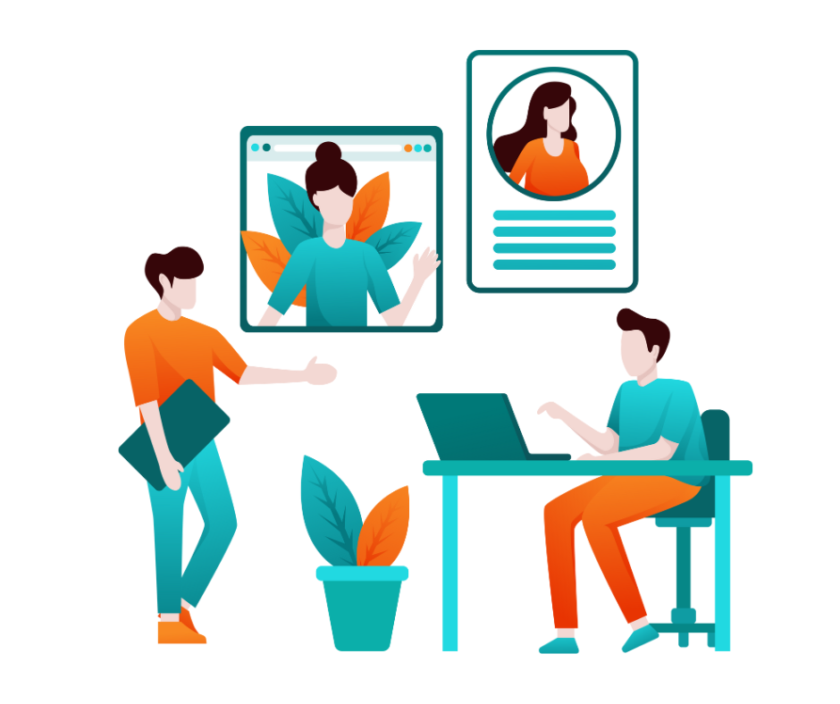

Building a great Online Presence is a challenging task. It is a crucial practice that allows you to build a strong personal brand, demonstrate your area of expertise & attract career opportunities that align with your goals & aspirations.
An online presence makes you visible to potential employers, clients, collaborators & peers who might be searching for professionals with your skills & expertise. It increases your chances of being discovered for career opportunities.
An active & engaging online presence allows you to build trust & credibility within your professional network. Now that we have known about the benefits of building an online presence, let us dive into the ways you can build a strong online presence.

Create a LinkedIn profile
A LinkedIn Profile is your door to many professional opportunities. Make sure to include all the elements needed to complete your profile.
You need to have a professional LinkedIn profile photo, LinkedIn profile summary, detailed work experience, skills, education & recommendations. All this will help you shape your LinkedIn Profile to attract visitors.

Develop a Personal Website or Portfolio
Building a Personal website or your portfolio might seem intimidating, but it is a great way to showcase your skills, all in one place! Unlike social media profiles or other platforms, a personal website gives you complete control over your brand image.
Through blog posts, articles, or resources shared on your website, you can demonstrate your expertise & establish yourself as a thought leader in your field. Your website content can prove to be a long-term asset as it remains accessible over a long period of time.

Engage in Social Media
Now that you have built your social media around your personal brand, it is time to showcase the true nature of your brand. Regular engagement with your audience gives a sense of personal touch to your brand & helps you become recognizable amongst the others.
This also provides you with opportunities to promote your personal brand & increase your visibility. It allows you to actively shape how you are perceived, connect authentically with your audience & leverage opportunities for growth & influence within your industry.

Contribute to Professional Blogs or Forums
Contributing to professional blogs or forums is valuable for building your personal brand as it helps you demonstrate your knowledge & expertise in your field.
Contributing to reputable blogs or forums can improve your online visibility through search engine optimization (SEO). Quality contributions can lead to backlinks to your own website or social media profiles, driving traffic & enhancing your overall online presence.

Join Professional Groups or Discussions
Professional groups provide a platform to connect with like-minded individuals, industry peers, potential clients, collaborators & mentors. Networking within these groups can lead to valuable relationships & opportunities that contribute to your personal brand development.
Professional groups also create opportunities for collaboration on projects, initiatives, or research within your field. Collaborating with others showcases your teamwork skills, expands your professional network positioning you as a collaborative & proactive contributor to the industry.

Publish Content on LinkedIn or Medium
Publishing articles or posts allows you to share your knowledge, expertise & unique insights on topics relevant to your industry or profession. It also allows you to connect with your audience directly.
Platforms like LinkedIn & Medium have large user bases & built-in audiences interested in professional development, industry trends & business insights. Publishing content on these platforms increases your visibility to a broader audience beyond your immediate network.

Regularly Update & Monitor your Profile
Regularly Google yourself to see what potential employers might find. Keep your profiles updated with your latest achievements, projects & skills. Stay active by sharing relevant news, articles & updates from your industry.

Conclusion
Building a strong online presence is something which requires great effort & consistency. It all starts with building a strong resume & a professional LinkedIn profile. We, at PaintMinds come to your rescue. With our team of experts who specialize in this, revamp your online presence to meet your career dreams.

Keywords: Professional Resume | area of expertise | LinkedIn profile | LinkedIn profile photo | LinkedIn profile summary
Title Tag: Build a strong Online Presence with these proven Tips!
Meta description: An online presence makes you visible to potential employers, clients, collaborators & peers who might be searching for professionals with your skills & expertise. Wondering how you can increase your chances of being discovered for career opportunities? Read this blog to know more.
Meta tag: Top 7 tips to build an Ultimate Online Presence | PaintMinds

